**UID EXP-1**

**-BY ROONEY BALA I**

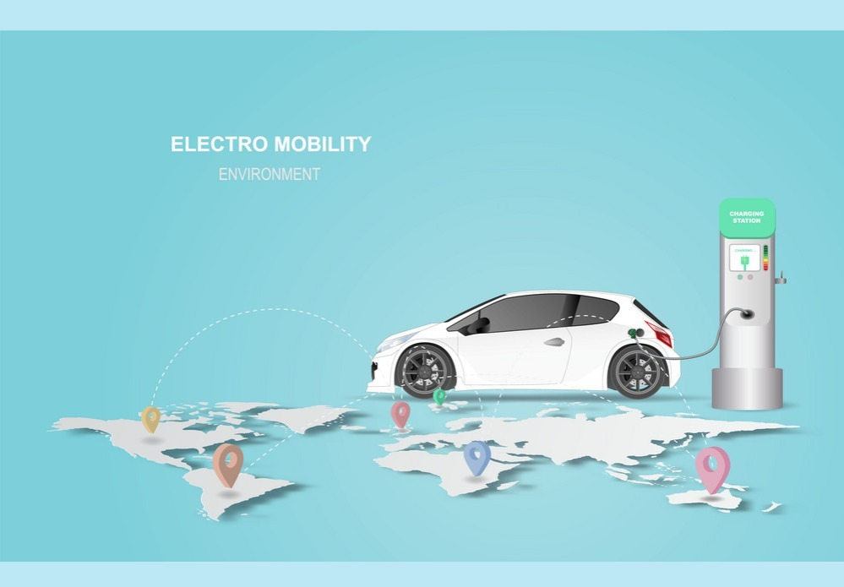

**This design lacks an appealing user interface. The image lacks informative content, only displaying the car’s image. To address this, the redesigned image features a diverse range of electric vehicles and their components, highlighting their electrical power sources. Additionally, the user can easily categorize their desired product by browsing through the intuitive and clear images representing each category.**